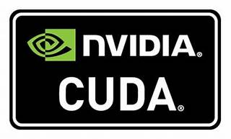

Explore

[**CUDA** is a parallel computing platform and application programming interface (API) that enables software to utilize certain types of graphics processing units (GPUs) for accelerated general-purpose processing, a concept known as **general-purpose computing on GPUs (GPGPU)**1](https://en.wikipedia.org/wiki/CUDA).

Here are **five free reference links** where you can learn more about CUDA:

1. [**Wikipedia: CUDA**](https://en.wikipedia.org/wiki/CUDA): This article provides an overview of CUDA, its history, and its role in parallel computing.
2. [**InfoWorld: What is CUDA? Parallel programming for GPUs**](https://www.infoworld.com/article/3299703/what-is-cuda-parallel-programming-for-gpus.html): A concise introduction to CUDA programming for GPUs.
3. [**NVIDIA Technical Blog: An Even Easier Introduction to CUDA**](https://developer.nvidia.com/blog/even-easier-introduction-cuda/): Step-by-step examples and parallel programming insights using CUDA C++.
4. [**NVIDIA Developer: CUDA Education & Training**](https://developer.nvidia.com/cuda-education-training): Access educational materials, video tutorials, and code samples to accelerate your applications.
5. [**NVIDIA Developer: CUDA Toolkit - Free Tools and Training**](https://developer.nvidia.com/cuda-toolkit): Explore tutorials, tools, and resources for CUDA development, including profiling, debugging, and optimization[2](https://developer.nvidia.com/cuda-education-training)[3](https://developer.nvidia.com/cuda-toolkit).

Happy learning! 🚀🔥